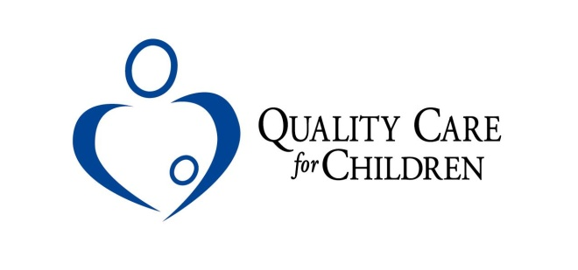

Quality Care for Children
Child Care Resource and Referral Agency
Job Description

It is the policy of Quality Care for Children that all employees shall receive an equal employment opportunity without regards to race, color, religion, veteran status, sex, national origin, age, marital status or disability in employment.

Job Title: Training Coordinator – Central West Region
Supervisor: Director of Family Child Care Services
Salary: Based on experience and education

Specific Responsibility:
- Conduct face-to-face training sessions throughout the Central West CCR&R Region
- Provide a training/learning environment that gives early childhood professionals hands-on training based on the most current research and practical information while adhering to Adult Learning Theory techniques
- Collaborate with other members of the QCC staff to renew expired training
- Work collaboratively with the Training Coordinators in each office to coordinate training sessions and ensure that all training needs and deliverables are met
- Develop training sessions/materials related to early learning/child care (beginning, intermediate, and advanced), to include the development of distance learning opportunities. Conduct TFT sessions for other QCC staff
- Manage the registration software (Eventbrite) for all 3 offices
- Manage the SquareSpace website pertaining to Training for all 3 offices including flyers and registration links
- Manage the training calendar pertaining to GaPDS for the Central West Region
- Manage the room reservation calendar for outside agencies
- Other duties as assigned

Requirements
- Bachelor’s Degree in Early Childhood Education, Child Development, or related field
- A minimum of 3 years prior experience providing early childhood professional development and training
- Must be able to meet the state trainer requirements as prescribed by the Georgia Department of Early Care and Learning (DECAL) as described at https://www.gapds.decal.ga.gov
- Demonstrate superior interpersonal and customer service skills in order to work with the community and state agencies on behalf of Quality Care for Children, families, and child care providers
- Knowledge of Georgia child care rules and regulations and early childhood best practices
- Must be a self-starter who works well with minimal supervision, as well as the ability to work in partnership with other team members
- Must have intermediate knowledge of Microsoft Office including Word, Excel, and PowerPoint; ability to use a networked database
- Must have a personal vehicle, valid Driver’s License and appropriate insurance

Physical Demands/Work Environment
- Frequent driving
- Consistently standing for 2 hours or more delivering training or facilitating meetings
- Sitting at the computer for 3 hours or more at a time
- Bending, frequent use of hands, stooping, and moderate lifting (at least 25 pounds) required
- Noise level in the work environment may be high at times

It is the policy of Quality Care for Children that all employees shall receive an equal employment opportunity without regards to race, color, religion, veteran status, sex, national origin, age, marital status, sexual preference or disability in employment.
The ideal candidate will be a team player exhibiting a positive attitude about their work while working confidently in a fast paced environment.

To Apply: Please email your resume and cover letter to HR@qccga.org (List: Training Coordinator in the email’s subject line). Please include your name when titling email attachments.

Resumes will be accepted until this position is filled. No phone calls please.

This position is subject to close at any time once a satisfactory applicant pool has been identified. No phone calls please.

